**1.INTRODUCTION**

**1.1 overview**

*This session introduce bank financial statements and provides a traditional, ratio-based procedure for analyzing bank financial performance using historical data. The banking industry world-wide is being transformed. The global forces for change include technological innovation; the deregulation of financial services at the national level and opening-up to international competition; and - equally important - changes in corporate behavior, such as growing disintermediation and increased emphasis on shareholder value. In addition, recent banking crises in Asia and Latin America have accentuated these pressures. The banking industries in central Europe and Latin America have also been transformed as a result of privatizations of state-owned banks that had dominated their banking systems in the past. In this project we are trying to analysis the bank related data and able to extract some insights from the data using Business Intelligence tools. To Extract the Insights from the data and put the data in the form of visualizations, Dashboards and Story we employed Tableau tool. Data are provided that compare the performance characteristics of small banks versus large banks and differentiate between high and law perfomers.*

**1.2 Purpose**

*1. If conducted internally, financial analysis can help fund managers make future business decisions or review historical trends for past success.*

*2. If conducted externally , financial analysis can help investors choose best possible investment opportunitie s.*

*3.Fundamenral analysis and technical analysis are the main types of financial analysis.*

*4.Fundamental analysis using ratios and financial statement data to determine the intrinsic value of a security.*

*5.Technical analysis assumes a security’s value is already determined by its price, and it focuses instead on trends in value over time.*

**2.Purpose**

**2.1 Empathy map**

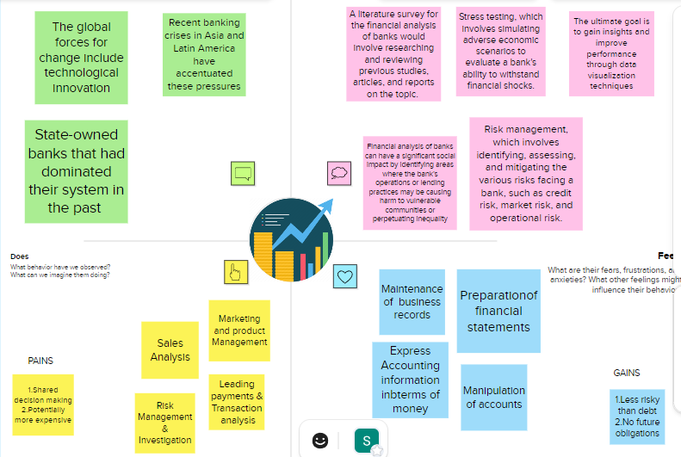

**2.2 Ideation & Brainstorming map screenshot**

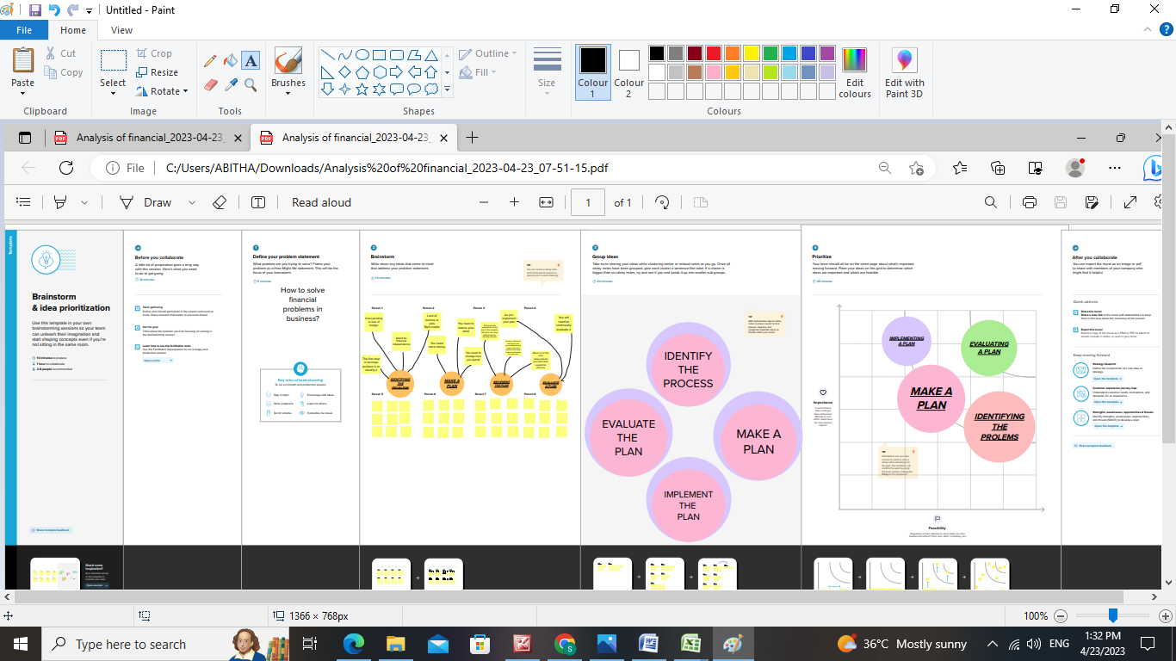

**3.Result**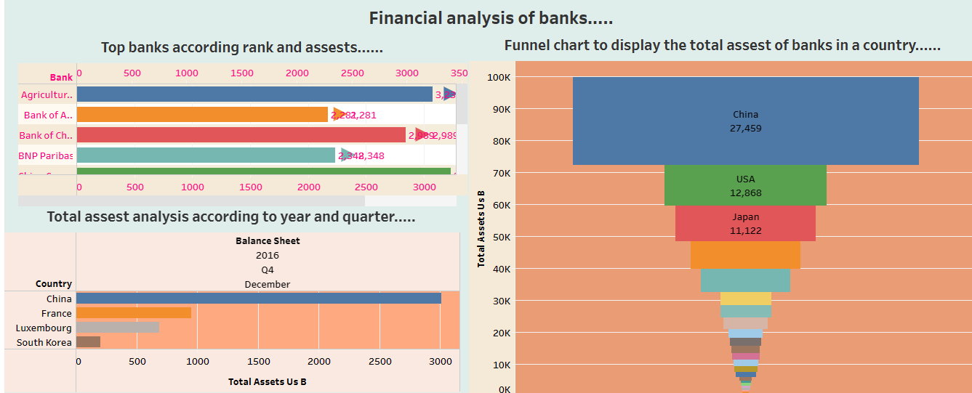

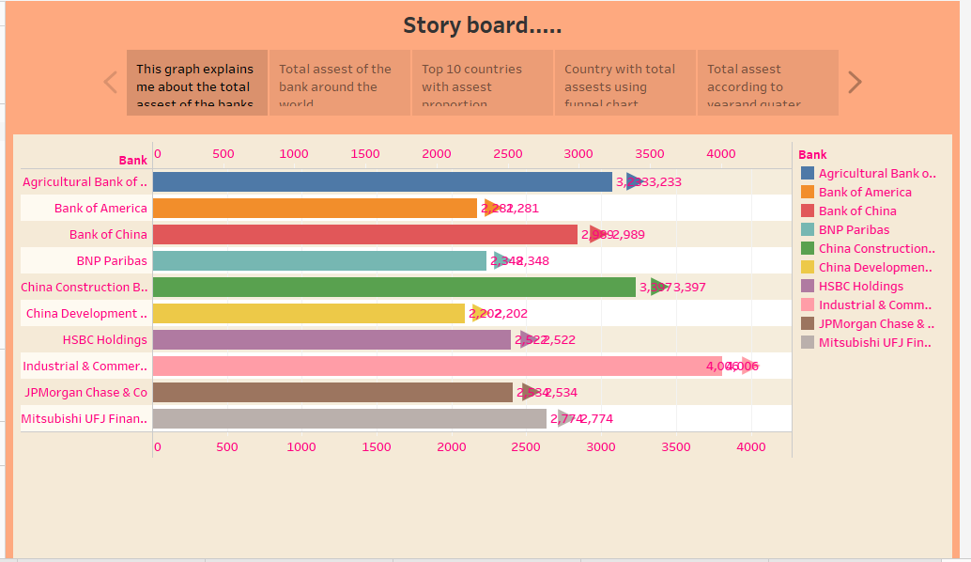

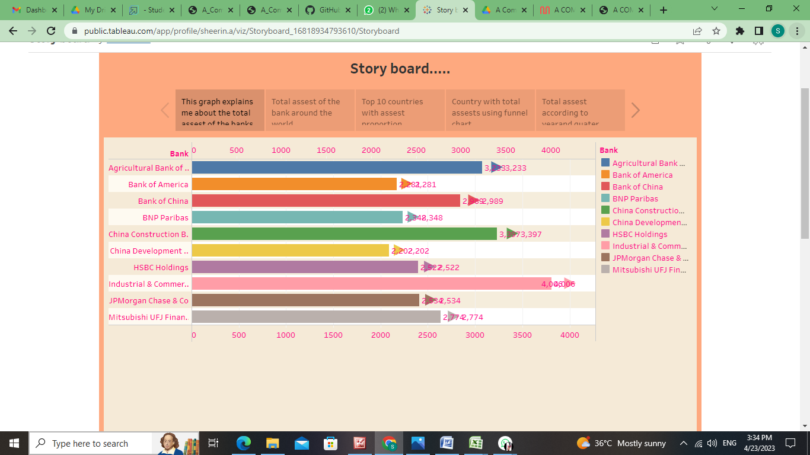

**4.Advantages and Disadvantages**

**Advantages**

*1. Safety of public wealth*

*2. Availability of cheap loans*

*3. Economies of large scale*

*4. Propellant of economy*

*5.Development in rural areas*

*6. Global reach*

**Disadvantages**

*1.Chances of banks going Bankrupt*

*2.Risk of fraud and Robberies*

*3.Risk of public debt*

**5.Applications of financial analysis banks**

*1. cyber security and fraud detection*

*2. chatbots*

*3. Loan and credit decisions*

*4. Tracking market trends*

*5. Data collection and analysis*

*6. Customer experience*

*7. Risk management*

*8. Regularity compliance*

*9. Predictive analysis*

*10. Process automation*

**5. Conclusion**

*It helps us to make sure that each member of the team has a specific role and responsibility that team members are compatible with each other and can work together harmoniously.*

*Mainly is very useful in job security.*

**7.Future scope**

*Global, digital banking users are expected to**cross the 3.6 billion-mark by 2024.*

*The statistic isn’t completely surprising, and in fact only reiterates what banks and the world in general has known for a while now; The future is digital and banking as a service open banking , and the booming fintech sector were not proof enough, we now have this roaring satsistic that puts a number to the future of banking.*

**8.Appendix**

**Source code**

